Beach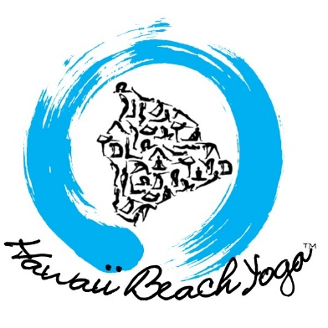Yoga
Sundays:
Morning Pranayama and Qigong 8:00-9:15am @ Honl’s Beach (Quan)

Mondays:
Morning Hatha Yoga 8:00-9:00am @ Honl’s Beach (Aya)
Sunset Mindfulness/Gentle Yoga 5:00-6:00pm @ Pahoehoe Beach Park (Sabine)

Tuesdays:
Morning Integrative Yoga 8:00-9:00am @ Honl’s Beach (SoulFire)
Sunset Hatha Yoga 5:00-6:00pm @ Honl’s Beach (Sherry)

Wednesdays:
Morning Hatha Yoga 8:00-9:15am @ Honl’s Beach (Suzy)
Sunset Hatha Yoga 5:00-6:00pm @ Honl’s Beach (Sherry)

Thursdays:
Morning Hatha Yoga 8:00-9:30am @ Honl’s Beach (Celeste)
Sunset Hatha Yoga 5:00-6:00pm @ Honl’s Beach (Sherry)

Fridays:
Morning Back & Hip Care Yoga 8:00-9:00am @ Honl’s Beach (Aya)

Saturdays:
Morning Hatha Yoga 8:00-9:30am @ Honl’s Beach (Kai)

Our Class Offerings:

*Hatha Yoga: Build strength and flexibility with a sequence of traditional physical postures done with special focus on your breath, to re-align your body and increase overall fitness, balance and energy.

*Pranayama/Qigong: Breathe in controlled patterns to increase overall health and lung strength and reduce stress and tension, with added circular, steady and fluid movements to open up your entire body.

*Back & Hip Care Yoga: Whether you have a sore back, tight or sensitive hips, or you're just looking to prevent injuries - this class will help your back and hips become more supple and flexible while remaining strong and stable.

*Mindfulness and Gentle Yoga: Explore yoga as a tool for self-discovery and an experience of cultivating mindfulness. You’ll put emphasis on maintaining a meditative state throughout this guided practice of gently flowing hatha yoga.

*Integrative Yoga: Heal yourself and bring unity to your body, mind, heart and soul. Enjoy this dynamic & energetic moving meditation for all levels. This class incorporates yoga styles of Hatha, Ashtanga, Vinyasa, Tantra, Kundalini, and Qigong!

